**. Biometrics, the role of theoretical biology in modern problems**

Many traits that lend themselves to automated recognition have been studied, including the face, voice, fingerprint, and iris. A key characteristic of our definition of biometrics is the use of “automatic,” which implies, at least here, that digital computers have been used.2 Computers, in turn, require instructions for executing pattern recognition algorithms on trait samples received from sensors. Because biometric systems use sensed traits to recognize individuals, privacy, legal, and sociological factors are involved in all applications. Biometrics in this sense sits at the intersection of biological, behavioral, social, legal, statistical, mathematical, and computer sciences as well as sensor physics and philosophy. It is no wonder that this complex set of technologies called biometrics has fascinated the government and the public for decades.

The FBI’s Integrated Automatic Fingerprint Identification System (IAFIS) and smaller local, state, and regional criminal fingerprinting systems have been a tremendous success, leading to the arrest and conviction of thousands of criminals and keeping known criminals from positions of trust in, say, teaching. Biometrics-based access control systems have been in continuous, successful use for three decades at the University of Georgia and have been used tens of thousands of times daily for more than 10 years at San Francisco International Airport and Walt Disney World.

There are challenges, however. For nearly 50 years, the promise of biometrics has outpaced the application of the technology. Many have been attracted to the field, only to leave as companies go bankrupt. In 1981, a writer in the New York Times noted that “while long on ideas, the business has been short on profits.”3 The statement continues to be true nearly three decades later. Technology advances promised that biometrics could solve a plethora of problems, including the enhancement of security, and led to growth in availability of commercial biometric systems. While some of these systems can be effective for the problem they are designed to solve, they often have unforeseen operational limitations. Government attempts to apply biometrics to border crossing, driver licenses, and social services have met with both success and failure. The reason for failure and the limitations of systems are varied and mostly ill understood. Indeed, systematic examinations that provide lessons learned from failed systems would undoubtedly be of value, but such an undertaking was beyond the scope of this report. Even a cursory look at such systems shows that multiple factors affect whether a biometric system achieves its goals. The next section, on the systems perspective, makes this point.

<https://www.ncbi.nlm.nih.gov/books/NBK219892/>

The distinct role of environmental technology

In line with the definitions above, environmental science, as the process of understanding how humans interact with the natural environment, and environmental technology, as the process of applying this understanding to address environmental challenges, can be distinguished as interdependent and complementary. Environmental science studies the mechanisms and processes underlying our interactions with the natural environment, the implications for the environment of the complexity and uncertainty brought on by economic, technological and social change (Walls, Brody, Dillon, & Stevenson, Citation2014); while environmental technology allows us to apply this knowledge and take the actions necessary to prevent, prepare for, or mitigate environmental risks. Environmental Technology has the potential to transform how we interact with nature and allow society to apply available scientific knowledge to truly progress; with “progress” an axiological or a normative concept, which should be distinguished from such neutral descriptive terms as “change” (Niiniluoto, Citation1995).

In practice and because of the wider science-technology convergence discussed above, environmental technology is increasingly being perceived as the products and services offered by the environmental sectorFootnote5, instead of the transformative process that can help society reach sustainability. The term is often used to refer to end of pipe solutions, technologies that curb pollution emissions by implementing add-on measures, and less frequently to those that mitigate the environmental burden of production and deliver cleaner production, reducing resource use and/or pollution at the source by using cleaner products and production methods. The EU’s Environmental Technology Action Plan (ETAP), defines environmental technology as “such products, systems, processes and services which provide clear environmental advantages compared to existing or alternative solutions, seen in a life cycle perspective. The approach shifts the focus from products to systems, resource efficiency and sustainable development.” In the large-scale technological systems of today, social institutions and technological hardware form a seamless web and any distinction between the “social” and “technological” dimensions of these systems becomes futile. Particularly when systems fail, attempts are made to blame casualties on either “human” or “technological” factors. Today, as the terms “environmental science and technology” are used interchangeably, or as one homogeneous phrase, the complex interactions between environmental science, technology and society are not easily recognized, rarely considered and often misunderstood.

What environmental technologies aim to achieve, what regulations aim to deliver, and the overall basis of how scientific knowledge is applied to address environmental challenges are seriously affected by how these challenges are defined. Problem framing implicitly shapes the options people consider or provides some measure of (non-) attainment with respect to those goals (O’Brien, Citation2000). Investments in abatement technologies have been generally seen as critical for reducing emissions from industry without compromising economic growth, although clean technologies are generally argued to be preferable to end of pipe solutions in the long run (Frondel, Horbach, & Rennings, Citation2007). It turns out that employing end of pipe solutions has been historically preferred not because of economic or environmental advantages but because of the way environmental problems have been often framed. For example, if water scarcity is addressed as a water availability challenge, desalination of seawater is an effective solution, providing a seemingly unlimited, constant supply of high-quality drinking water without impairing natural freshwater ecosystems (Voulvoulis, Citation2012). However, if the problem is framed as the sustainable provision of water, desalination has potential negative impacts arising from increased demand and usage (Palmer, Menninger, & Bernhardt, Citation2010), including issues with brine production and the need for management of the costs and impacts of the additional wastewater produced (Voulvoulis, Citation2015). Instead, if the problem is framed as water security (including availability and demand), other options arise. System boundaries can tip the scales in favor of one solution over another. Figure 2 shows various examples where system boundaries have been drawn around a simple model for optimizing wastewater treatment in at least nine different ways in fourteen publications on water quality management. Different choices in setting these boundaries will inevitably affect the results, leading to different solutions (Kirk et al., Citation2005; Ahmed, Citation2011).

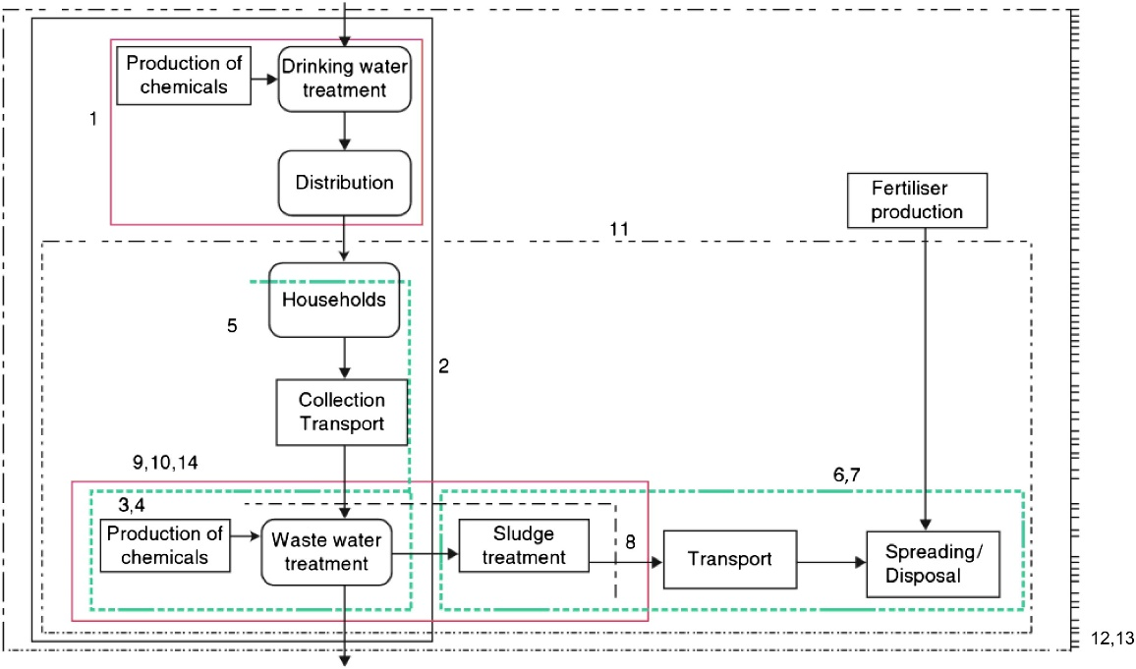

Figure 2. An illustration of how solutions depend on the way problems are framed, or in this case how setting system boundaries leads to different solutions in water quality management as reported in different studies (1. Van Tilburg (Citation1997); 2. Crettaz et al. (Citation1997); 3. Roeleveld et al. (Citation1997); 4. Fava et al. (Citation1994); 5. Ashley et al. (Citation1997); 6. Matsuhashi et al. (Citation1997); 7. Neumayr et al. (Citation1997); 8. Mels et al. (Citation1999); 9. Ødegaard (Citation1995); 10. Dennison et al. (Citation1997); 11. Dalemo et al. (Citation1997); 12. Tillman et al. (Citation1998); 13. Bengtsson et al. (Citation1997); 14. Grabski et al. (Citation1996)), adopted from Kirk et al. (Citation2005) and Ahmed (Citation2001).

*Environmental technology as problem solving*

A way to contextualize the distinct roles of environmental science and technology when dealing with sustainability challenges is through gap analysis from a systems perspective (Figure 3). Conceptualising these challenges as the gap between the current situation; where we are now (unsustainable state A), and the desired state; where problems have ceased to exist; where we want to be (sustainable state D), these challenges can be better defined. The gap between these two states (extent of the problem), can also be a deviation from a norm, standard, or status quo, a desired state defined by society. Environmental technology as problem solving becomes the process of transition from unsustainable system state (A) to sustainable system state (D). There can be several solutions (the means to close the gap or correct the deviation), but social difficulties arise where such means are not obvious, are not immediately available, or when there is disagreement over the preferred solution.

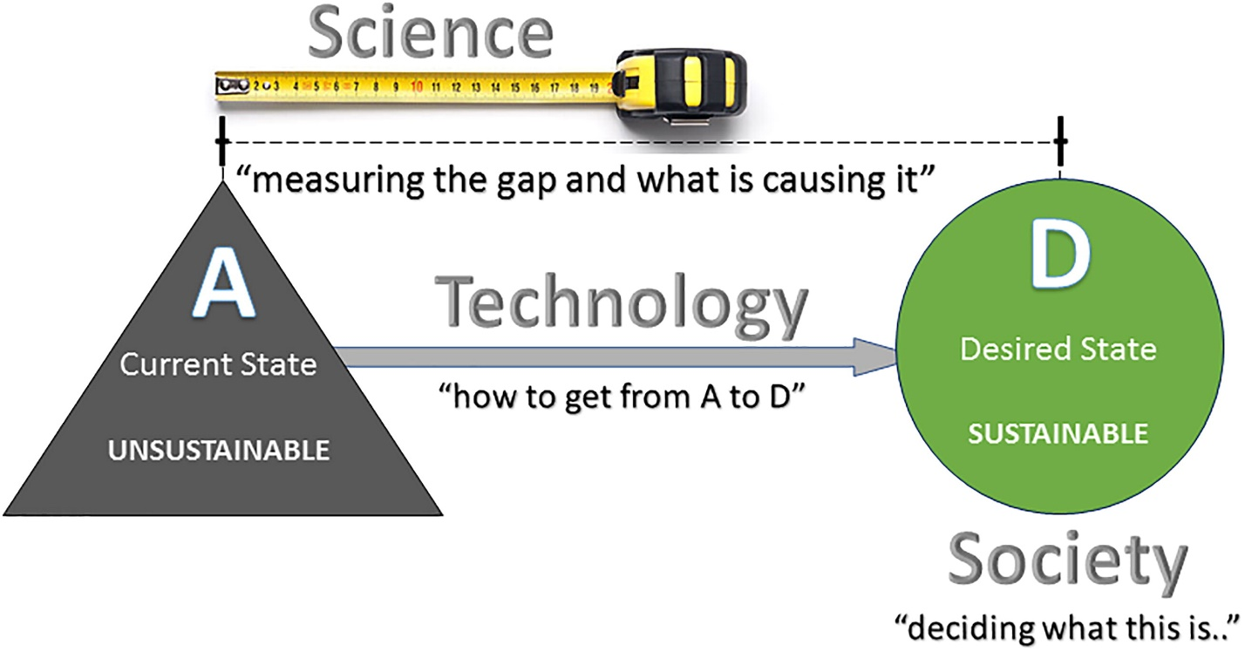

Figure 3. Conceptualising the relationship between science, technology and society in addressing sustainability challenges.

Science has a role to play in helping us understand why we are where we are (State A), and how far this is from where we should/desire to be (State D), as defined by society. The complexity of environmental problems denotes that understanding is a prerequisite for solving (Pavlovskaia, Citation2014). Beyond appreciation of diverse knowledges, ideas and values of sustainability, there is a need to “take plural pathways seriously,” as no matter how specific the context, there is never only one relevant, viable path (Scoones et al, Citation2018). To allow for this and enable the appropriate technology, Funtowicz and Ravetz (Citation1994a) proposed extending the peer community to include scientists together with industry, government, citizen groups and environmental organizations (Funtowicz & Ravetz, Citation1993; Funtowicz & Ravetz, Citation1994a, Citation1994b, Citation1994c).

<https://www.tandfonline.com/doi/full/10.1080/10643389.2019.1565519>